Rationale
Literacy underpins a school curriculum by developing students’ ability to read, write, speak and listen for a wide range of purposes, and is a key element in enabling them to develop into effective learners across the curriculum. Across all departments, all teachers have a vital role to play in supporting students’ literacy development. Unlocking the language of each subject is essential to understanding, whether that is grasping the vocabulary of science, mathematics, or engineering. For most students, how literate you are – the breadth and depth of your vocabulary – correlates with your success in many subjects.
National context
In 2021, over 120,000 disadvantaged students made the transition from primary to secondary school below the expected standard for reading. The educational prospects for this group are grave. If their progress mirrors previous cohorts, we would expect 1 in 10 to achieve passes in English and maths at GCSE, and fewer than 2% to achieve the English Baccalaureate.
Brook Sixth Form & Academy context
A significant proportion of students that join Brook 6th Form & Academy at the start of Year 10 and Year 12 have a reading age below their chronological age. The low reading age of these students has a direct impact on their literacy skills. The low reading age impacts on the students’ vocabulary and, in turn, their ability to write effectively using appropriate academic and subject specific language. Oracy skills are equally affected. Whilst students may seem articulate, their limited vocabulary hinders their ability to achieve high levels of academic success.
It is also important to note, that even for those students who are reading at their chronological age on entry to Brook Sixth Form & Academy, the impact of the COVID-19 pandemic will mean that the vast majority of students require support in further developing their literacy skills in order to achieve the academic outcomes that they are capable of.

Our Approach
All teachers within the academy are responsible for the delivery of the four key Literacy strands in their subject area:
- Vocabulary
- Reading
- Writing
- Oracy
It is important to note that literacy skills are explicitly developed in KS4 students via the delivery of GCSE English Language and Literature, as well as GCSE Media. The further development of KS5 students’ literacy skills will be dependent on the approach outlined above.
Students identified with a low reading age by the Accelerated Reader programme tests will be provided with additional support to improve their reading.
Vocabulary
Aim (Intent)
We need to get children undertaking lots of rich, academic talk, but this alone will prove insufficient. Children also need to read widely – learning the rare words found in fiction and non-fiction texts, but seldom used in our daily talk. Of course, it can be hard for a child to read more challenging texts if their vocabulary is limited. By combining academic talk, reading, as well as undertaking explicit vocabulary instruction, we take a deliberate and intentional approach to language development that benefits every child.
Approach (Implementation)
- Word of the Week: Tier 2 Vocabulary, that is high frequency words found in many different subject disciplines. For example: algorithm, correlate, differentiate, neutralise, trajectory
  - Provided by English department (in collaboration with subject Leads)
  - Referred to in Form time
  - Displayed on academy screens and classroom displays
  - Used by departments within the subject in the given week
  - To be included in extended pieces of writing, such as the Big Write
- Tier 2 Cross curricular Instructional words: For example: describe, explain, analyse, evaluate, compare, demonstrate, concede, conclude, implication, consequent, differentiate, simplify
  - To be contextualised as part of the teaching of the subject
  - To be explicit in the panning of the sequencing of lessons
- Subject specific terminology: Tier 3 vocabulary. For example: photosynthesis, ergonomics, anthropometric, concordant, photoelectric, positron, integration, modal, median, python, Java, phagocytosis, titration, transpiration
  - To be contextualised as part of the teaching of the subject
  - To be displayed in the teaching room

- Marking of students to include the use of the Literacy key (Assessment Policy)
  - Must be explicit on the marking of the Big Write
  - Must be included on Milestone Assessments
  - Must be included on one piece of assessed work (other than Big Write and Milestone Assessments)
Impact (Monitoring)
- Evidence of understanding of instructional language: Work scrutiny
- Evidence of subject specific vocabulary in the Big Write: Work scrutiny
- Evidence of subject specific vocabulary in student presentations and writing: Work scrutiny
- Classroom displays reflecting academy approach to vocabulary: Learning Walks
- Evidence of use of extended (tier 2 and 3) vocabulary by both students and the teacher in Learning Walks and Lesson Observations
- Over time, improvements in whole school attainment and KS5 progress outcomes.
Reading

Aim (Intent)
Our ambition is to create a culture of reading for enjoyment and equip students with the skills to become competent academic readers.
As previously outlined, a proportion of the students that join Brook 6th Form & Academy start with low prior attainment in reading. In the first instance we need to teach the students to read, introducing an expectation of reading independently. This needs to be followed by the teaching of subject specific reading skills that will allow the students to become academic readers, thereby equipping them with the skills that they need to achieve in their subjects and successfully progress to their next steps destinations.
We acknowledge that teachers should be supported to understand the fundamental ways in which students learn to read, and the most common barriers to doing so. A major part of the challenge of literacy in secondary schools is related to the demands of academic reading. Whilst some students may learn to navigate subject specific texts naturally, others are likely to struggle, particularly when asked to work independently.
Academic reading is challenging because it requires students to actively engage with complex subject specific texts. For most students, reading comprehension is much more challenging than verbal comprehension, which typically contains less technical language. Students need to engage with what they are reading, drawing on what they already know and making new inferences to learn more.
Our aim is twofold:
- Firstly, to teach general reading ability, though practice, and create a culture of reading for pleasure. This has been the academies current interventionist approach.
- Secondly, to enhance the reading ability of all students to make them competent academic readers. This is the next step in the academy’s approach to ensuring that all students make excellent progress using reading as a skill.
Approach (Implementation)
- A more effective use of the Accelerated Reader Programme:
  - Explicitly teaching students the skills of completing a reading assessment to produce a more accurate picture of their reading ability
  - Diagnostic reading test of all new students on entry (Year 10 and Year 12) to identify students that require additional support
  - Use the Accelerated Reader Programme to develop identified students general reading skills
  - Greater use of Reading Room and introduction of book clubs
  - Reading in Form time for all students for 20 minutes at least three times a week
  - Evaluation of the effectiveness of the Accelerated Reader Programme over time
- Implementation of Academic Reading skills in all subject areas in lessons:
  - Providing students with reading materials in advance of the lesson
  - Reading as part of lessons, actively supported by the teacher
  - The implementation of the Reciprocal reading approach, that is, questions, predictions, clarifying and summarising
- Enhancing reading skills through the annotation and contextualising of subject specific texts
- Enhance the delivery of literacy skills as part of the teaching of EPQ, as a number of the literacy skills required for effective reading are implicit within the subject
Impact (Monitoring)
- An increase in the reading ages of students at least equal to the chronological timeline
- An increase in the reading ages of identified students that exceeds the chronological timeline.
- Students making good academic progress across internal assessments over time
- Learning Walks and Lesson Observations will evidence teachers actively supporting reading as part of the lesson
- Learning Walks and Lesson Observations will evidence implementation of the Reciprocal Reading approach as part of the lesson
- Excellent destinations data. All students achieve the academic qualifications to successfully progress to appropriate destinations at the end of Year 13, namely: Apprenticeships and University.

Writing

Aim (Intent)
Writing is vital to academic success as it is identified as one of the most important requirements a student must fulfil to be able to thrive academically and beyond. It improves a student’s ability to recall information, make connections between different concepts and synthesize information in new ways. In effect, writing is not just a tool to assess learning, it also promotes learning.
Writing is demanding because it requires students to combine three processes.
- Students must be able to transcribe, that is, physically write or type
- Students must be able to compose, generating ideas and translating them into words, sentences and structured texts.
- Students must use executive functions, to enable them to make plans, motivate themselves and review and redraft texts.
When we write, certain areas of our brain are activated. So, the more frequently you write, the more the whole of your brain is enhanced to generate novel ideas that can be applied to solving real-life problems.
At Brook 6th Form & Academy our aim is to create effective communicators, readers, writers and thinkers. The curriculum will provide our students with the knowledge and skills to establish them as effective writers. Writing has been deeply integrated into the school curricular as a way to significantly improve the communication skills of students. It provides students with the avenue to learn all the rules of the language and how they can better organise their ideas more coherently using the language.
It is important to note that writing includes work produced using a computer. For example, the use of Tier 2 and Tier 3 vocabulary is relevant in all writing, regardless of how it is produced. However, as a significant part of external assessments, and as a key skill required by both employers and universities, all students must be provided with regular hand-writing opportunities, alongside the requirements of the Big Write (refer to page 7).
Approach (Implementation)
Teachers can help students with the challenge of writing in several ways, but a common theme running through effective forms of writing instruction is that they support students to break down complex writing tasks and help them to become fluent in as many of the processes involved in writing as possible.
- All subjects must teach writing and provide regular writing opportunities
- Teachers must provide sentence starters (as appropriate), model paragraphs and model essays before students begin the writing task
- The teacher must ensure that students understand the Tier 2 cross curricular Instructional words
  - For example: describe, explain, analyse, evaluate, compare, demonstrate, concede, conclude, implication, consequent, differentiate
- The teacher must ensure that the students are using planning strategies, such as graphic organisers, before they start the writing tasks. For example:
  - Mind maps
  - Tables Flow chart
  - Bullet points
  - Headings
  - Venn diagram
  - Persuasion map
  - Sequence chart
  - Timeline
- Peer assessment of the writing task:
  - Students making comparative judgements of each other’s work
  - Students peer assess writing tasks, identifying three areas to improve (that are not related to content)
- Teacher assessment of the writing task:
  - Teachers must build in time for peer assessment of writing tasks
  - All subjects must mark for literacy
  - Provide opportunities for students to respond to and act upon (edit and redraft) guidance/feedback (teacher or peer)
  - Consistently challenge students to produce higher quality written work

- The Big Write
  - The Big Write takes place once every term to ensure that students are able to write extended pieces of writing which are technically accurate in terms of paragraphs, sentences, vocabulary, spelling, punctuation and grammar, whilst also including subject specific content.
  - The Big Write highlights to students that writing is not a task simply for GSCE English and Media, whilst also providing an opportunity for all students in the academy, across all subjects, to logically express their viewpoints through writing.
Impact (Monitoring)
- Over time there should be a measurable improvement in the quality of students written work.
  - For example: effective use of paragraphs, sentences, vocabulary, spelling, punctuation and grammar.
  - Clear evidence of high quality extended pieces of writing, such as essays, Engineering reports and the Big Write itself.
- Evidence of understanding of instructional language: Work scrutiny
- Evidence of subject specific vocabulary in the Big Write: Work scrutiny
- Evidence of subject specific vocabulary in student presentations and writing: Work Scrutiny
- Overtime, improvements in whole school attainment and KS5 progress outcomes.

Oracy (speaking and listening)
Aim (Intent)
Oracy is essential to students’ thinking and learning and to their productive engagement in the classroom. It is an important skill which we need to support our students to achieve since we believe that high quality classroom talk raises standards across all subjects.
Talk, when delivered skilfully, is a powerful tool for formative assessment. It is a powerful way to provide constructive and positive feedback. It can be an effective means of re-engaging the disengaged and closing the gaps of equity and attainment. Therefore, effective oracy ensures better academic outcomes and greater self-confidence, enabling young people to access and thrive in their learning.
The Social Mobility Commission has found that strong communication skills are important for improving social mobility and workplace opportunities (DFE, 2019). One of the biggest barriers to students’ achievement in life is a lack of clarity when they talk. Employers put good oral communication at the top of their requirements for employees.
Our aim at Brook 6th Form & Academy, therefore, is to elevate oracy to the same status as reading and writing. Our classrooms should be rich in talk, in which questions are planned, peer conversations are modelled and scaffolded and teachers use talk skilfully to develop students’ thinking.
Approach (Implementation)
- Student presentations. A skill to be delivered and practised:
  - Year 12 students will be taught during EPQ and Literacy for Engineers
  - KS4 students will be taught as part of GCSE English and Media
  - Computer Science sequencing of lessons should include how to use technology to support presentation skills
  - Practice of these skills should be across all subject areas
  - Practice of these skills should be included in all Employer-led and University-led projects
- Reading complex academic texts during lessons. Supported teacher/student led discussions
- All staff members to model appropriate use of language in all verbal communications with students and each other
- KS4 students to participate in Jack Petchy Speak out Loud
Impact (Monitoring)
- We should see powerful presentations delivered by students:
  - EPQ
  - Assemblies
  - Classroom presentations
  - Employer led projects
  - To Governors and external stakeholders
  - Recruitment events on behalf of the Academy
- A measure of success in external competitions that require effective oracy skills.

Appendix 1: Examples of Graphic Organisers
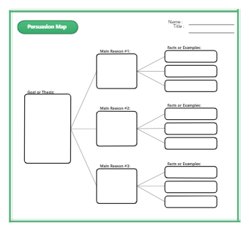
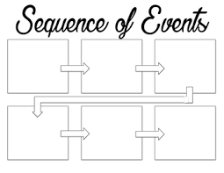

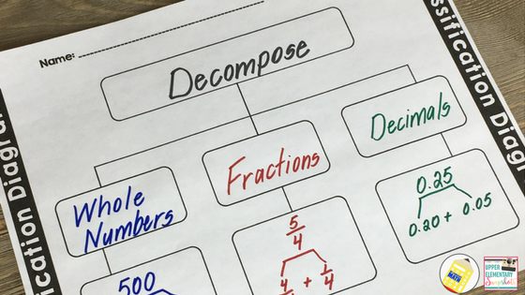
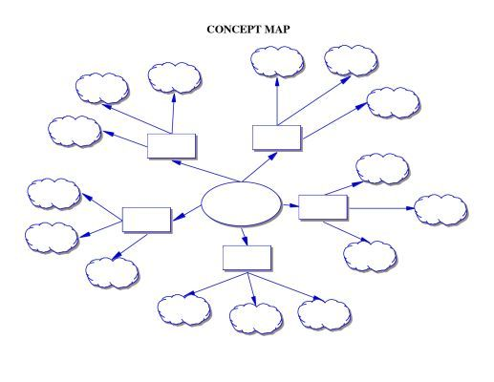

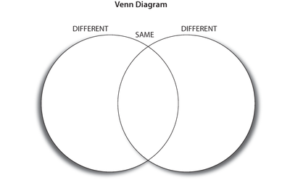

Policy Name: | Literacy Policy
Policy Reviewed: | July 2022
Next Review:
Signature of Governors Curriculum Committee: | Signature of Principal:

Education Endowment Foundation 2021
Alex Quigley, 2020
Overtime a bank of Tier 2vocabulary/words will be compiled and added to this document as an appendix

