Mission and Commitment
At Brook Sixth Form & Academy, we firmly expect 100% attendance from all students. Regular and punctual attendance is critical to ensuring every student can achieve their full academic and personal potential. Our policy reflects the importance of students being present every day to take full advantage of the educational provision and grasp opportunities to fulfil their full potential.
We stress that 100% attendance and if it begins to fall below 100% it will be reviewed in detail, and immediate action will be taken to address any concerns. Students missing lessons risk falling behind academically, socially, and emotionally. The habits formed now mirror the expectations of future employers, reinforcing our students’ readiness for the world of work.
There is no reason for students not to achieve full attendance. Parents/carers must ensure, wherever possible, that appointments are scheduled outside of school hours to minimise disruptions to their child’s education.
Members of Brook Sixth Form & Academy Staff with Responsibilities for Attendance School
Mr D Buja – Assistant Principal (DSL) Lead of Attendance – d.buja@brooksixthform.com
Mrs L. Radhakrishnan – Attendance Officer – Office@brooksixthform.com or 020 3773 4670– please contact Mrs. L. Radhakrishnan with any questions or when reporting your child’s absences
Please note, Pastoral Leads are available should you need more detailed support for attendance
Mrs A. Odonkor – KS4 Pastoral Lead – ac.odonkor@brooksixthform.com
Mrs R Khan – KS5 Pastoral Lead – ro.khan@brooksixthform.com
Attendance & Absence
If you know your child is going to be absent from school due to illness, medical appointments or for any other reason, please contact the school on the first day of absence by calling 0203 773 4670 and selecting option "1."
If the school does not receive a phone call from the parent or carer, a call will be made home from the school.
- Written notification of the absence period and the reason for this from the parent/guardian is required on the first day of the pupil’s return.
- Medical appointments should, where possible, be arranged outside school time. (when this cannot be avoided, a medical card must be provided as evidence).
- Absences of 5 days or more must be supported by medical evidence or where patterns of absence are shown.

Punctuality
Being on time is vital and we expect all pupils to attend school regularly and to be punctual for the start of the school day which starts at 8:25am. If your child is late for any reason, they need to sign in at reception with a valid reason.
Students must be on-site by 8:25 AM, and in form registration seated for an 8:30 AM start. Any lateness disrupts the learning environment and will be addressed as follows:
- 1x Late in a Week: 15-minute after-school detention.
- 2x Lates in a Week: 45-minute detention the following Wednesday.
- Persistent Lateness (5 Times): Parental meeting and one week of detention.
- 10+ Lates: Isolation and further parental involvement.
Students arriving after 9:30 AM will be marked as absent for the session.
This will impact your child’s overall attendance figure and could lead to a Penalty Notice. Medical appointments should be scheduled outside of school hours whenever possible. If this is not feasible, your child should attend school before and after the appointment.
Morning Attendance & Punctuality Recording Procedure
1. Purpose of the Procedure
This procedure outlines the daily operational expectations for the monitoring and recording of student attendance and punctuality at Brook Sixth Form & Academy. Ensuring consistency, accuracy, and timely communication is essential for safeguarding, academic accountability, and maintaining the school’s high attendance standards.
2. Morning Procedure (Daily Operations)
Protected Calling Time (9:00 a.m. onwards)
- After 9:00 a.m., protected time begins for the Key Stage Pastoral Leads to make home calls regarding student absences.
- Once students are settled into Period 1:
  - Mrs Khan will begin calls for Year 12.
  - Mrs Odonkor will begin calls for Year 13 and Year 11.
- The priority is to identify absences promptly and ensure that parents are contacted at the earliest opportunity.

3. Follow-Up Actions and Communication
- Any students for whom contact has not been successful must be passed on to Leela.
- During Period 1 (after 9:00 a.m.):
  - Mrs Radhakrishnan will send SMS messages to parents of:
    - Students who have arrived late to school.
    - Students absent without parental contact.
Standard SMS Message
“Your child arrived late to school today and will serve a 15-minute detention after school. Please discuss this with your child to ensure they arrive on time.”
This ensures punctuality consequences are communicated swiftly and consistently.
4. Form Tutor Responsibilities – Registers & Punctuality Recording
Form tutors play a central role in the accuracy and reliability of attendance data. All punctuality and attendance monitoring begins with the information recorded during morning registration.
Key Expectations for Form Tutors:
- Registers must be completed accurately at the start of Form Time, which begins at 8:30 am.
- If a student arrives late to form time, this is recorded as late to school.
- Students must report to their form tutor if they arrive late before 9:00am.
- Once registered are completed, BromCom will be initiated to send text messages to parents based on the information recorded during form time.

5. Importance of Accurate Register Keeping
Registers are a legal document and a critical safeguarding tool. The accuracy of attendance and punctuality recording has a direct impact on:
- The effectiveness of our follow-up procedures
- The clarity of communication with parents
- Student accountability through consequences and interventions
- Safeguarding oversight and statutory compliance

Registers tell a story, and that story begins with the form tutor.
Their precision and timeliness ensure that the school responds appropriately to lateness and absence every single day.

Absence During Term Time
Attendance is crucial for academic success and prepares students for life beyond school and into their future careers. Staff at Brook Sixth Form work diligently with families to support their child’s attendance, especially on the rare occasion when it is low.
Reporting Attendance:
If your child will be absent from school due to illness, medical appointments, or any other reason, please notify the school on the first day of absence.

Contact Information:
- Phone: Call 020 8554 3608 and choose option "1"
- Email: Alternatively, email us at Office@brooksixthform.com

If the school does not receive any communication from the parent or carer, a call will be made home from the school.
Important: Written notification of the absence period and the reason for the absence from the parent or guardian is required on the first day of the pupil’s return.
Please note: Absences of 5 days or more must be supported by medical evidence or where patterns of absence are shown.
Evidence can be (however not exclusive to):
- Doctors notes
- Prescriptions
- Labels from medicine that have a date within the absence period
- Appointment letters
- Referral letters
The importance of attendance
The general guidance for excellent attendance is that students should attend school at least 96% of the time. This equates to no more than 8 days of absence across an academic year. Below is a summary that shows how many hours of learning your child will miss when they do not attend school.
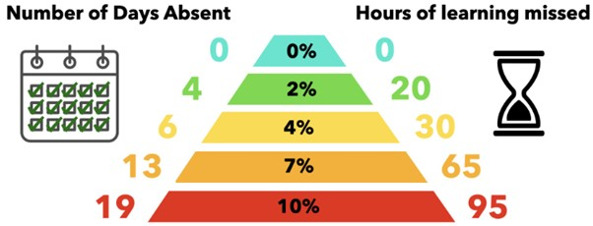

Medical appointments:
We understand that medical appointments may be hard to come by; you could wait weeks to see your GP and often hospitals will book appointments during school time. However, we do stress that, where possible, you seek medical appointments outside of school time and during holidays. Any medical appointments during the school day require evidence, without this we cannot authorise the absence. Students should, where possible, not be out all day for medical appointments and either come to school before hand, or return afterwards to maximise learning time.
Evidence can be (however not exclusive to):
- Doctors notes
- Prescriptions
- Labels from medicine that have a date within the absence period
- Appointment letters
- Referral letters
Term time leave:
Holidays should NOT be arranged in term time as this disrupts a pupil’s education. Any request for withdrawal of a pupil during term time, except for exceptional reasons, will not be granted and parents may be liable to a Fixed Penalty Notice as per the Barking and Dagenham Attendance Strategy and Code of Conduct.
If your child is absent before or after a school holiday, we must see evidence for the absence. This may be medical evidence if your child is unwell, or evidence of flight delays or circumstances beyond your control.
We cannot authorise any absences before or after a holiday without this evidence and you risk being issued with a penalty notice.

Monitoring Attendance Flowchart
This flowchart outlines the staged process we follow when a student’s attendance begins to decline. It ensures early identification, clear communication with families, and timely support. All actions must be logged on CPOMS and monitored through Bromcom to maintain a consistent and accountable system.
Stage 1 - Early Warning (Attendance Falls Below 96%)
Trigger: Student’s attendance drops below 96%.
Actions:
- Form Tutor initiates Stage 1 intervention.
- Parent/Carer is contacted via a partial concern call.
- The conversation and concerns are logged on CPOMS.
- Form tutor monitors attendance for a 2-week period and maintains contact with student.
Outcome:
If attendance improves → Stage 1 closes.
If no improvement after 2 weeks → Case escalates to Stage 2 and referred to the Pastoral Lead of Key Stage 4/5.

Stage 2 - Persistent Absence Identified (Below 90%)
Trigger: Attendance falls below 90%, becoming Persistent Absence (PA) as defined by the DfE.
Actions:
- Pastoral Key Stage Lead contacts the parent/carer to discuss concerns.
- Student is placed on a formal Attendance Report, monitored daily.
- School Attendance Lead letter is sent home.
- Case remains under Pastoral Key Stage Lead monitoring for 2 weeks.
- Educational Welfare Officer (EWO) is notified at this point.
Outcome:
if attendance improves → Stage 2 closes.
If attendance continues to fall below 90% → escalate to Stage 3.

Stage 3 - Persistent Absence (Continued Below 90%)
Trigger: After Stage 2, attendance remains below 90% with no improvement escalated to Head of Key Stage
Actions:
- Mandatory meeting with:
  - Head of Key Stage
  - Mr Buja (Attendance Lead & DSL)
  - Parent/Carer
- Barriers to attendance are explored thoroughly.
- Strategic interventions are agreed and monitored over a further 2-week period.
- An Attendance Action Plan is agreed with the student and parent.
- EWO Local Authority Letter is issued to formally document concerns.
Outcome:
Improvement → Remain at monitoring level until consistent.
Continued decline → Case escalates to Stage 4.

Stage 4 - Severe Persistent Absence (Continued Below 90%)

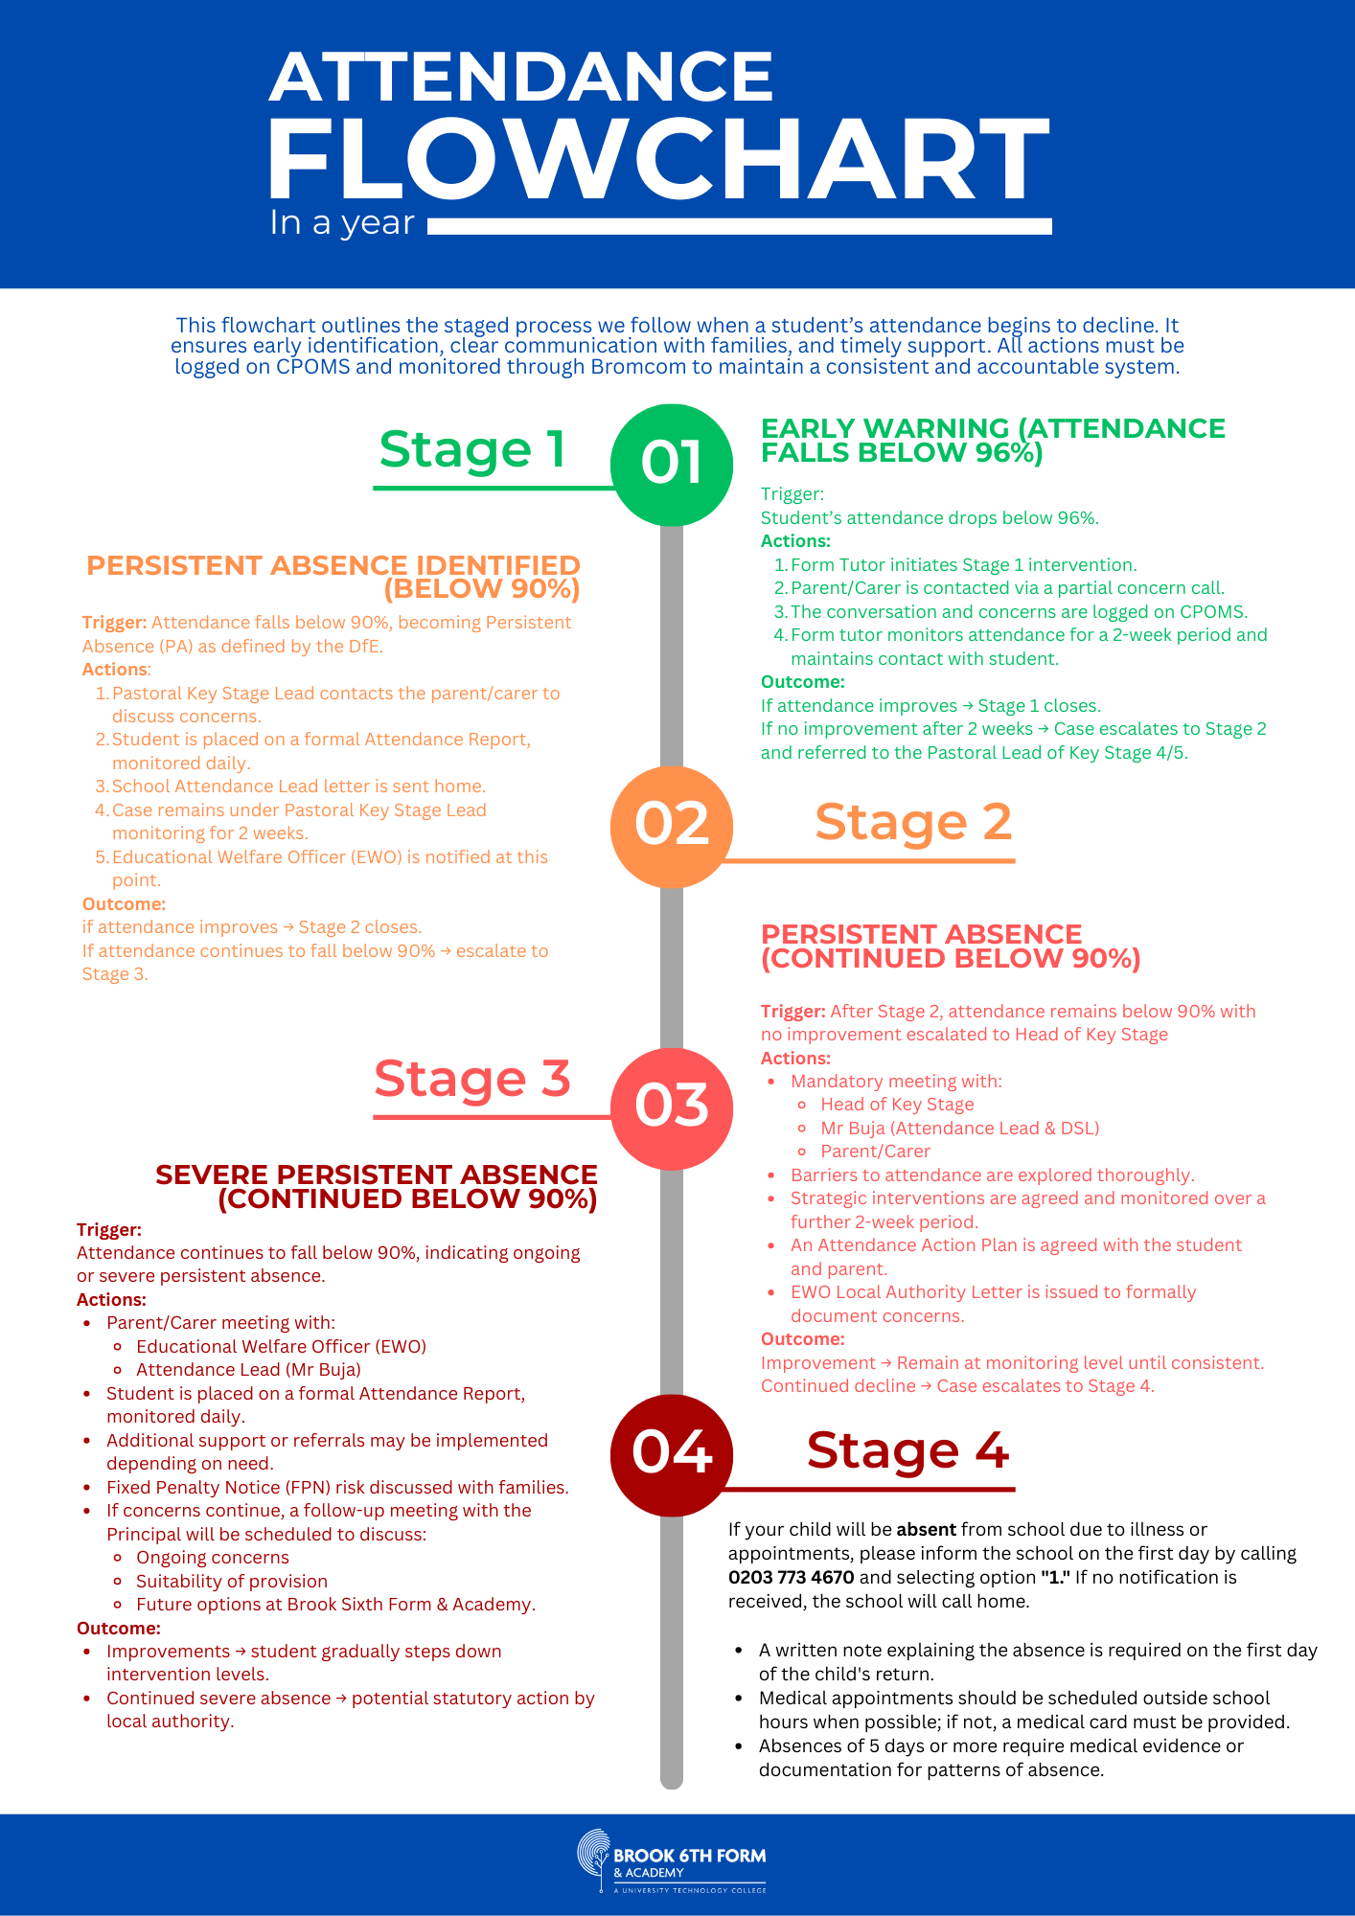
Legal Framework
Attendance changes – From August 2024
The Department for Education (DfE) has introduced new guidance for schools on managing attendance, including a national framework for penalty notices. These changes take effect from 19 August 2024. At Brook Sixth Form and Academy, we adhere to the LBBD Attendance Strategy and Code of Conduct. You can find our school’s attendance policy on our website.
Parents/carers are legally responsible for ensuring their child’s regular attendance, as stipulated by the Education Act 1996 and the Children Act 1989/2004.
You may be fined or prosecuted if your child is regularly absent without the school’s permission. For further information on Parental Responsibility please refer to attendance parental responsibility measures.
Failure to ensure a child’s attendance is treated as an absolute offence, which can lead to legal action by the Local Authority. Penalty notices of £160 per parent, per child (£80 if paid within 21 days) may be issued, and further non-compliance can result in prosecution. Brook Sixth Form & Academy will work with families to remove barriers to attendance while upholding these legal obligations.

Legal Action and Penalties
Brook Sixth Form & Academy reserves the right to refer cases of poor attendance or persistent lateness to the Local Authority. Legal actions may include:
- Fixed Penalty Notices: Issued for unauthorised absences.
- Prosecution: Under Section 444 of the Education Act 1996 for non-compliance.
All parents have a legal duty to ensure that their child receives an education suitable to his/her age, ability and aptitude and any special needs You could face legal action if your child does not attend school regularly and on time.

If you are sent to court, you may:
- be fined up to £2,500; and/or
- get a three months prison sentence.

Once your child is registered at a school, you are legally responsible for making sure they attend regularly.
With the introduction of the new National Framework for Penalty Notices, the following changes will come into force after 19th August 2024.
Fixed Penalty Notices can be issued when a student has:
- 5 consecutive days of term time leave
- 10 sessions of unauthorised absence in a 10-week period
First offence
- The first time a Penalty Notice is issued for unauthorised absence or term-time leave.
- Fine is: £160 per parent per child if paid within 28 days.
- There may be a discount to £80 if paid within 21 days for the first offence (varies by local authority).
Second Offence (within 3 years)
- The second time a Penalty Notice is issued for the same child within a 3-year rolling period.
- Fine is £160 per parent per child, with no discounted amount available.
Third Offence and Any Further Offences (within 3 years)
- On the third time within the same 3-year period, no further Penalty Notice is issued.
- Instead, the case goes to a Magistrates’ Court for prosecution.
  - Courts can impose fines up to £2,500 per parent per child.
  - Convictions may appear on future DBS certificates and affect employment/visa checks.

Attendance Categories
Our expectations are clear: students must maintain 100% attendance. Any deviation will trigger a review and necessary intervention.
- Expected Attendance: 100%
- Good Attendance: 97-99%
- Attendance of Concern: 94-96%
- Unsatisfactory Attendance 91-93%
- Persistent Absence: Below 90% (Persistent Absence)
Students with unsatisfactory attendance will be monitored closely, and parents/carers will be contacted to address concerns and agree on an improvement plan.
Reporting Absences
Parents/carers must notify the school of any absence by 9:00 AM on the first day. Absences exceeding five consecutive days require medical evidence.
- Authorised Absences: Illness (with evidence), medical appointments, bereavement, and religious observances.
- Unauthorised Absences: Term-time holidays, shopping trips, birthdays, or minor illnesses without a medical note.
Unauthorised absences may result in sanctions, including penalty notices issued by the Local Authority.
Monitoring and Persistent Absence
Students with attendance below 90% are classified as persistently absent. Persistent absence will trigger:
- Meetings with the student and parents/carers.
- Referral to the Education Welfare Officer (EWO).
- Implementation of targeted interventions, including attendance contracts.
Continued non-compliance will result in escalation to the Local Authority, potentially leading to legal action.
Rewards for Excellent Attendance
To encourage and celebrate high attendance, Brook Sixth Form & Academy offers:
- Termly Recognition: Certificates for 100% attendance.
- Assemblies: Special mention for consistent attendance.
- Privileges: Non-uniform days and exclusive events.
Truancy
Brook Sixth Form & Academy enforces a zero-tolerance policy on truancy. If a student is caught truanting, the incident will be recorded via CPOMS and the student will be sent to reflection.
A meeting will then be arranged with the student, their parents/carers, and DSL and the Pastoral Lead to address the issue and agree on corrective actions.
Home Visits and Safeguarding
In cases of persistent absence or safeguarding concerns, home visits may be conducted by two staff members. These visits ensure students are safe and supported in overcoming attendance barriers.
Data Monitoring and Analysis
The Assistant Principal reviews attendance data weekly and produces detailed termly reports. These reports identify trends and inform strategic interventions. Priority is given to vulnerable students, including those with special educational needs or safeguarding concerns.

Date of Approval Full Governing Body | January 2026
Date of next biennial review | January 2028
Principal
Chair

STAGE 1 – Letter
Dear Parent/Carer,
Re: Attendance Concern – Attendance Below 90% (Persistent Absence Status)
I am writing to inform you that your child’s attendance has fallen below 90%, which is classified by the Department for Education (DfE) as Persistent Absence. This level of attendance is extremely concerning and requires immediate improvement.
At Brook Sixth Form & Academy, we set our expectations at a high attendance standard of 100% (excluding extenuating circumstances). This reflects the high academic demands of Sixth Form study and the level of professionalism required to prepare students for university, apprenticeships, and employment. Falling below this level significantly affects progress, outcomes, and safeguarding oversight.
Why This Requires Immediate Action
Students who are absent begin to fall behind in content coverage and assessment preparation. Attendance below 90% means your child has already missed a considerable amount of learning time. Research shows that poor attendance directly correlates with:
- Lower attainment
- Reduced progression opportunities
- Poorer study habits
- Increased stress and falling behind peers
We cannot support your child effectively if they are not present.
Intervention Stage
Your child has now moved into Stage 2: Persistent Absence Monitoring.
Over the next two weeks:
- The Key Stage 5 Pastoral Lead will closely monitor their attendance.
- Any further absence will be reviewed immediately.
- Attendance expectations will be reinforced and support offered where appropriate.
If attendance does not improve rapidly, this will escalate to Stage 3,
Continued poor attendance may result in:
- Local Authority intervention
- Attendance panel meetings
- Fixed Penalty Notices, in line with national guidance
What we require from you
- All absences must be reported on the same day.
- Medical evidence must be provided for illness-related absences.
- Your child attends school every day unless this is absolutely unavoidable.
- You communicate any concerns affecting attendance immediately.

We are committed to supporting your child, but sustained improvement must now be seen.
Yours sincerely,
Mr Daniel Buja
Assistant Principal – Attendance & Safeguarding
Brook Sixth Form & Academy

STAGE 2 – LETTER
To be sent by RKH/AOD + Attendance Lead referenced

Brook Sixth Form & Academy
[Address]
[Date]

Dear Parent/Carer,

Re: Stage 2 Attendance Concern – Persistent Absence

We are writing to inform you that your child’s attendance has fallen below 90%, which is identified nationally as Persistent Absence. At Brook Sixth Form & Academy, students are expected to meet a minimum standard of 98% attendance due to the academic intensity and professional expectations of Sixth Form study.

Falling below 90% means your child has now missed significant learning time, and we must act immediately to prevent further decline.

What Happens at Stage 2

Your child has now entered Stage 2: Persistent Absence Monitoring.
Over the next two school weeks:

- The Pastoral Lead of KS4/5 will closely monitor their attendance.
- An Attendance Action Plan may be agreed with your child.
- Any further absences will be reviewed and must be supported with evidence.
- The School Attendance Lead letter has now been issued as a formal warning.
- The Educational Welfare Officer has also been informed of the concern at this stage.

Required Parent/Carer Responsibility

Please ensure that:

- Your child attends school every day unless unavoidable.
- You report absences on the morning of the first day.
- Medical evidence is provided where required.
- You contact us if your child is experiencing difficulties affecting attendance.

Next Steps if Attendance Does Not Improve

If attendance does not show rapid improvement over the next two weeks, your child will move to Stage 3, which includes a formal meeting with the Attendance Lead (Mr Buja).

We look forward to working with you to secure immediate improvement.

Yours sincerely,
[Pastoral Key Stage Lead]

Cc: Mr Daniel Buja, Attendance Lead & Assistant Principal

STAGE 3 LETTER – Continued Persistent Absence (No Improvement After Stage 2)

Formal meeting required with Attendance Lead
Brook Sixth Form & Academy
[Address]
[Date]

Dear Parent/Carer,
Re: Stage 3 Attendance Escalation – Formal Attendance Meeting Required

Despite earlier intervention, your child’s attendance remains below 90%, with insufficient improvement during the Stage 2 monitoring period. This level of non-attendance is severely affecting their academic progress and is of increasing concern.
Brook Sixth Form maintains a high expectation of 100% attendance for all students. A continued pattern of absence suggests that your child is at significant risk of falling behind.

Stage 3 Actions
Your child’s case has now been escalated to Stage 3. This requires:

A formal attendance meeting with:
- Head of Key Stage
- Mr Daniel Buja (Attendance Lead & Assistant Principal)
The purpose of this meeting is to:
- Identify barriers affecting attendance
- Agree a structured Attendance Improvement Plan
- Review any required support or intervention
- Set clear expectations for immediate improvement
An Educational Welfare Officer (EWO) letter is now being issued to mark the seriousness of the situation.

Why This Must Be Addressed Immediately
Failing to attend school regularly has a long-term impact on:
- Academic outcomes
- Coursework completion
- Exam readiness
- Post-18 pathways including university and apprenticeships

If Attendance Does Not Improve After Stage 3
If attendance continues to fall or fails to improve within the agreed monitoring period, your child’s case will be escalated to Stage 4, which may involve:
- A meeting with the Educational Welfare Officer
- Daily Attendance Report
- Possible Fixed Penalty Notice
- A further meeting with the Principal to review future placement at Brook Sixth Form

We urgently request your support in ensuring your child attends every day.

Yours sincerely,
Cc: Mr Daniel Buja, Attendance Lead & Assistant Principal
Cc: Educational Welfare Officer

STAGE 4 LETTER – Severe Persistent Absence (High-Risk Case)
Meeting with EWO + risk of FPN + Principal involvement
Brook Sixth Form & Academy
[Address]
[Date]

Dear Parent/Carer,

Re: Stage 4 – Severe Persistent Absence (Urgent Action Required)

Your child’s attendance has now reached a level of Severe Persistent Absence, with attendance remaining below 90% despite multiple interventions. This is now a serious safeguarding and academic concern.
At Brook Sixth Form, our expectation remains 100% attendance, and your child is currently well below this threshold.

Mandatory Stage 4 Actions
Your child is now required to attend a formal meeting with:
- Educational Welfare Officer (EWO)
- Mr Daniel Buja, Attendance Lead & Assistant Principal
- Head of Key Stage
At this meeting, your child will be placed on a Formal Attendance Report, monitored daily.

Consequences of Continued Absence

If attendance does not improve immediately, the following actions may be taken:
- Referral to the Local Authority Attendance Team
- Fixed Penalty Notice issued in accordance with DfE guidance
- Escalation to a Principal’s Meeting to discuss:
  - Suitability of continued study at Brook Sixth Form
  - Suitability for national examination entry
  - Further enforcement action
  - Next steps for the student’s educational placement
This is now the final stage before potential statutory action.

Immediate Parental Action Required
We ask that you:
- Ensure your child attends every day without fail
- Provide medical evidence for all illness-related absences
- Communicate with us urgently regarding any barriers to attendance
Your support at this critical stage is essential.

Yours sincerely,
Mr Daniel Buja
Assistant Principal – Attendance, Behaviour & Safeguarding
Attendance Lead

Cc: Head of Key Stage
Cc: Educational Welfare Officer
Cc: Principal

