Physics SOW & Required Practical (2022-2023): Y11

AQA GCSE: 8463
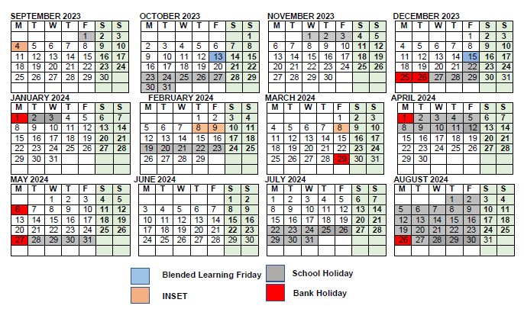
QAN code: 601/8751/7
Year 10:
1. Energy
2. Electricity
3. Particle model of matter
4. Atomic structure

Year 11: (green=covered)
5. Forces
6. Waves
7. Magnetism and electromagnetism…
8. Space physics (physics only)

Week | Date | Topic |  | Additional notes
W1 | 04-09-23 | - N/A  - 8.1 Vectors and scalars/8.2 Forces between objects |  | Monday (4th ) INSET day  5. Forces  Spec_code: 4.5.1.1 to 4.5.7.3
W2 | 11-09-23 | - 8.3 Resultant forces  - 8.4 Moments at work
W3 | 18-09-23 | - 8.6 Centre of mass  - 8.7 Moments and equilibrium
W4 | 25-09-23 | - 8.8 Parallelogram of forces  - 8.9 Resolution of forces
W5 | 02-10-23 | - Summary and review  - 9.1 Speed and distance-time graph
W6 | 09-10-23 | - 9.2 Velocity and acceleration  - 9.3 Velocity and acceleration II |  | Blended learning: Friday 13th
W7 | 16-11-23 | - 9.4 Analysing motion graphs  - Summary and review/ EOU Test
W8 | HT  (23-10-23)
W9 | HT  (30-10-23)
W10 | 06-11-23 | - FD and review  - 10.1 Forces and acceleration | GCSE Engineering  Aerodynamics: 3.4.3 | Student learn lift, drag & thrust in Physics and Engineering
W11 | 13-11-23 | - 10.2 Weight and terminal velocity  - 10.3 Forces and breaking
W12 | 20-11-23 | - 10.4 Momentum/10.5 Using conservation of momentum  - 10.6 Impact forces/10.7 Safety first
W13 | 27-11-23 | - 10.8 Forces and elasticity  - Buffer
W14 | 04-12-23 | - 11.1 Pressure and surfaces/ 11.2 Pressure in liquid  - 11.3 Atmospheric Pressure/ 11.4 Up thrust and flotation |  | Blended learning: Friday 15th
W15 | 11-12-23 | - Summary and review  - EOU test  - RP6 Investigating the relationship between the force and extension of a spring
W16 | 18-12-23 | - FD and gap analysis  - Buffer  - RP7 Investigation between force and acceleration |  | School breaks on Thursday 21^{st:}
W17 | HT  (25-12-23) |  |  | Winter break:  BANK holiday Monday 25th and Tuesday 26th
W18 | HT  (01-01-24) |  |  | BANK holiday Monday 1st
 |  |  |  | Schools opens Tuesday 4th of Jan
W19 | 08-01-24 | - 12.1 The nature of waves/12.2 The properties of waves  - 11.3 Reflection and refraction |  | 6. Waves  Spec_code: 4.6.1.1 to 4.6.2.6
W20 | 15-01-24 | - 12.4 Sound waves  - 12.5 The use of ultrasound/ 12.6 Seismic waves
W21 | 22-01-24 | - Summary and review  - Buffer
W22 | 29-01-24 | - 12.1 The electromagnetic spectrum  - 12.2 Light, IR, MW and RW | GCSE Biology  The eye: 4.5.2.3 | In Physics, students learn how eye detect visible light though cone and rods, but very briefly. This learning is extended in Bilogy
W23 | 05-02-24 | - 12.3 Communications  - 12.4 UV, X-rays and gamma rays  - RP8 Investigating plane wave in a ripple tank |  | INSET day Thursday 8th and Friday 9th  RP8 would be done in W26, Some apparatus parts are broken, should get them by the end of the half term
W24 | 12-02-24 | - 12.5 X-rays in medicine  - Summary and review | GCSE Biology  Cancer: 4.2.2.7 | How ionization radiation destroys cells and leads to mutation, this understanding is further extended in Biology
W25 | HT  (19-02-24) | Higher tier only:  - 16.1 Formation of solar system  - 16.2 The life history of a star/ 16.3 Planets, satellite and orbits  - 16.4 The expanding universe/ 16.5 The beginning and the future of the universe |  | 7. Space  Spec_code: 4.8.1.1 to 4.8.2
W26 | 26-02-24 | - 13.1 Magnetic fields /13.2 Magnetic fields and electric currents  - 13.3 Electromagnets in devices | GCSE Engineering  Electrical systems: 3.3.2 | INSET (20-02-23 Friday)  8. Magnetism and  Electromagnetism  Spec_code: 4.7.1 to 4.7.3.4  Electrical systems such as power supplies (mains and batteries), input control devices (for example relays and switches), output devices (motors, buzzers, bells, lamps and solenoids).
W27 | 04-02-24 | - 13.4 The motor effect  - 13.5 the generator effect  - RP 10 investigating IR |  | INSET day Friday 8th
W28 | 11-03-24 | - 15.6 The alternating-current generator  - 15.7 Transformers and uses of transformers
W29 | 18-03-24 | - 14.1 Reflection and refraction of light  - 14.2 Light and colour |  | Lenses  spec-code: 4.6.2.5 to 4.6.2.6
W30 | 25-03-24 | - 14.3 lens/ 14.4 uses of lens  - RP9 Investigation of refraction and reflection  - Summary and review |  | BANK holiday Friday 29th
W31 | HT  (01-04-24) |  |  | Easter break:  BANK holiday Monday 1st
W32 | HT  (08-04-24)
W33 | 15-04-24 | - Revision  - Revision
W34 | 22-04-24 | - Revision  - Revision
W35 | 29-04-24 | - Revision  - Revision
W36 | 06-05-24 | - Revision  - Revision |  | BANK holiday Monday 6th
W37 | 13-05-24 | - Revision  - Revision
W38 | 20-05-24 | Paper 1
W39 | HT  (27-05-23) | BANK holiday Monday 27th
W40 | 03-06-23 | - Exam  - Exam
W41 | 10-06-23 | - Exam  - Exam
W42 | 17-06-23 | - Exam  - Exam
W43 | 24-06-23 | - Exam  - Exam
W44 | 01-07-23 | - Exam  - Exam
W45 | 08-07-23 | Paper 2
W46 | 15-07-23 | - Exam  - Exam
W47-52 | 22-07-23  END of the academic Year | Summer break: School breaks Friday 19th

