Physics SOW & Required Practical (2022-2023): Y13 (A2)

AQA A-level Physics: 7408
Year 13: (green covered)
- Particles and radiation
- EM radiation and Q phenomena
- Waves
- Mechanics
- Materials
- Electricity
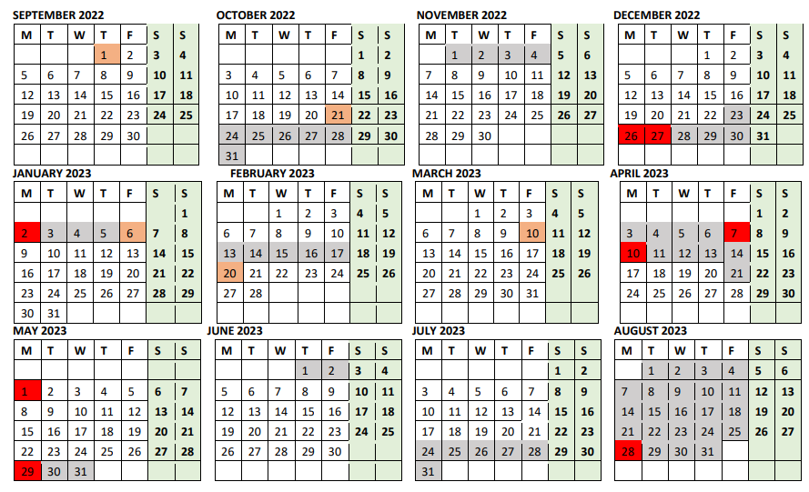

7. Further mechanics
13. Astrophysics (option)
8. Gravitational and electric field
9. Electromagnetism
10. Capacitors
11. Nuclear physics…
12. Thermal physics

Week | Date | Topic | Cross-curricular | Additional notes/spec code
W1 | 04-09-23 | - N/A  - Recap of Further Mechanics  - FD and gap analysis |  | Monday (4th ) INSET day  7. Further mechanics  Spec_ref: 3.6.1.1 to 3.6.1.4
W2 | 11-09-23 | - 13.1 Optics and optical telescope Recap  - 13.2 Comparing telescopes  - 13.3 Parallax and parsecs |  | 13. Astrophysics  Spec_ref: 3.9.1.1 to 3.9.3.4
W3 | 18-09-23 | - 13.4 Magnitude  - 13.5 Stars as black bodies  - 13.6 Stellar classification
W4 | 25-09-23 | - A-level Paper 1 test  - FD and gap analysis  - 7.5 The mass Spring System as SHO
W5 | 02-10-23 | - 13.7 Evolution of stars  - 13.8 Doppler shift and redshift  - 13.9 The Big bang theory
W6 | 09-10-23 | - 13.10 Detection of binary stars, quasars and exoplanets  - Summary & review  - EOU test |  | Blended learning: Friday 13th
W7 | 16-10-23 | - FD and gap analysis  - RP7: Investigation of Mass Spring System & Simple Pendulum System  - Buffer |  | CPAC assessed  CPAC 1a, CPAC 1b, CPAC 3a, CPAC 4a, CPAC 4b and CPAC 5b.
W8 | HT  (23-10-23)
W9 | HT  (30-10-23)
W10 | 06-11-23 | - 8.1 Gravitational field  - 8.2 Gravitational field Strength  - 8.3 Gravitational Potential |  | 8. Gravitational and  electric field
W11 | 13-11-23 | - 8.4 Orbits  - 8.5 Electric Fields  - 8.6 Electric Potential
W12 | 20-11-23 | - 8.7 Comparing Electric and Gravitational Fields  - Review & EOU Test  - FD and gap analysis
W13 | 27-11-23 | - 9.1 Magnetic flux density  - 9.2 Forces on charge particles  - 9.3 Electromagnetic induction |  | 9. Electromagnetism Spec_ref: 3.7.5.1 to 3.7.5.6
W14 | 04-12-23 | - 9.4 Faraday’s and Len’s law  - RP10 Investigating Force on a Current-carrying Wire  - RP11 Investigating Flux Linkage with a Search Coil |  | Blended learning: Friday 15th  Will take place on W16  and
W15 | 11-12-23 | - 9.5 AC  - 9.6 Transformers  - Review & EOU
W16 | 18-12-23 | - FD and gap analysis  - 10.1 Capacitors  - 10.2 Energy stored by capacitors  - 10.3 Charging and Discharging | Maths  Edexcel 9MA0  Section 1.6: Exponentials and logarithms | 10. Capacitors  Spec_ref: 3.7.4.1 to 3.7.4.4  School breaks on Thursday 21st
W17 | HT  (25-12-23) |  |  | Winter break:  BANK holiday Monday 25th and Tuesday 26th
W18 | HT  (01-01-24) |  |  | BANK holiday Monday 1st
 |  |  |  | Schools opens Tuesday 4th of Jan
W19 | 08-01-24 | - 10.4 Time constant, time half and dielectric  - Buffer  - N/A |  | Finished Capacitors.  We are about 2 weeks behind due to changes in the time table of INSET days and extra-curricular activities
W20 | 15-01-24 | - RP9 Investigating Capacitors Discharging  - Summary & review  - EOU test |  | To be carried out on W23
W21 | 22-01-24 | - 11.1 The Atomic Nucleus  - 11.2 Nuclear Radius and Density  - 11.3 Properties of Nuclear Radiation |  | 11. Nuclear physics  Spec_ref: 3.8.1.1 to 3.8.1.8
W22 | 29-01-24 | - 11.4 Background radiation and intensity  - 11.5 Exponential Law of Decay  - 11.6 Half-life and its Applications
W23 | 05-02-24 | - 11.7Nuclear Decay  - 11.8 Mass defect and the binding energy  - 11.9 Nuclear Fission and fusion |  | INSET day Thursday 8th and Friday 9th
W24 | 12-02-24 | - 11. 10 Nuclear Fission Reactor  - Buffer
W25 | HT  (19-02-24)
W26 | 26-02-24 | - Buffer  - 11.11 Nuclear Physics Summary  - EOU test  - RP12 Investigating the inverse square law
W27 | 04-03-24 | - 12.1 Thermal energy transfer  - 12.2 The three gas laws  - 12.3 The ideal gas equation | Chemistry  The ideal gas equation: 3.1.2.3 | 12. Thermal physics  Spec_ref: 3.6.2.1 to 3.6.2.3  INSET day Friday 8th
W28 | 11-03-24 | - 12.4 Kinetic theory and the pressure of an ideal gas  - 12.5 Kinetic energy of gas molecule  - Summary and review | Chemistry  Relative atomic mass and relative molecular mass:  3.1.2.1  The mole and the Avogadro constant: 3.1.2.2
W29 | 18-03-24 | - RP8: Experimental Investigation of Boyle’s Law, and Investigation of Charles Law  - EOU test  - FD and gap analysis
W30 | 25-03-24 | - Buffer  - Buffer  - Buffer |  | BANK holiday Friday 29th
W31 | HT  (01-04-24) |  |  | Easter break:  BANK holiday Monday 1st
W32 | HT  (08-04-24) | - Revision and catch-up: 3 days
W33 | 15-04-24 | - Paper 2 test  - FD and gap analysis  - Buffer
W34 | 22-04-24 | - Revision  - Revision  - Revision
W35 | 29-04-24 | - Revision  - Revision  - Revision
W36 | 06-05-24 | - Revision  - Revision  - Revision |  | BANK holiday Monday 6th
W37 | 13-05-24
W38 | 20-05-24 | - Revision  - Revision  - Revision
W39 | HT  (27-05-23) |  |  | BANK holiday Monday 27th
W40 | 03-06-23
W41 | 10-06-23 | Paper 1
W42 | 17-06-23
W43 | 24-06-23
W44 | 01-07-23 | Paper 2
W45 | 08-07-23
W46 | 15-07-23 | Paper 3
W47-W52 | END of the academic Year | Summer break: School breaks Friday 19th

